**News Waves : Navigate the News Landscape**

**(React Application)**

**Introduction**

**Project Title :** News Waves: Navigate the News

**Team member and their role** :

|  |  |  |
| --- | --- | --- |
| Role | Name | E-mail |
| Team Leader | AKSHAYA VARUNIE M U | varunieakshaya@gmail.com |
| Team member | Angelin Selvi A | angelinselvi1189@gmail.com |
| Team member | Archana R | archanaramu.bsc4@gmail.com |
| Team member | Aslin Ravista J | aslinravista17@gmail.com |

**Project Overview**

**Purpose:**

News Wave is a news application designed to provide users with real-time news updates. The platform allows users to browse news articles, subscribe for updates, and navigate seamlessly through various sections of the application. It aims to offer a smooth user experience with well-organized news content and intuitive navigation.

**Goals :**

Our key goals include:

* **Deliver Reliable News –** provide accurate timely, and well-researched news across multiple platforms.
* **Enhance public Awareness –** Keep audiences informed about local, national, and global events.
* **Encourage Critical Thinking –** Promote independent analysis and factc-based discussion.
* **Leverage Digital Media –** Utilize social media, video content, and AI-driven tools for better engagement.
* **Foster Community Engagement –** Encourage audience participation through discussions, opinion pieces, and interactive content.

**FEATURES:**

* **Develop a News platform:** Create a website or app for publishing news articles, videos, and live updates.
* **Ensure credibility :** Implement fact checking mechanisms to  maintain journalistic integrity.
* **Increase Audience Reach:** Use SEO, social media marketing, and partnerships to expand the viewer base.
* **Adapt to trends :** Integrate AI tools for personalised news recommendations and automated summaries.

**Functionalities:**

* News Watching: Users can browse through the latest news articles from various sources.
* Subscription for Updates: Users can subscribe to receive regular news updates.
* Header and Footer Navigation: Ensures smooth movement across different sections of the app.
* Multiple Pages with Proper Redirection: Supports structured navigation between news categories.
* API Integration with NewsAPI: Fetches the latest news dynamically using the NewsAPI service.
* Search Functionality: Users can search for specific news topics or keywords.
* Category Filters: Allows users to filter news based on categories like Technology, Sports, Business, etc.

**ARCHITECTURE**

**COMPONENT STRUCTURE:**

The application is structured into major React components, including:

* Header & Footer: Common navigation components that ensure a consistent user experience.
* News Feed: Displays dynamically fetched articles based on API responses.
* Subscription Form: Allows users to enter their email and subscribe for updates.
* Navigation: Manages routing and ensures users reach the right pages.
* Search Bar: Enables users to look up specific news articles.
* Category Filters: Lets users filter news based on interests.

**State Management:**

State is managed using React’s built-in state management tools:

* useState Hook: Manages local component states.
* Context API: Used to maintain global state for shared data like user preferences and subscriptions.

**Routing:**

React Router is used to handle page navigation and ensure seamless transitions between different sections of the app. Each page is mapped to a specific route, ensuring the correct redirection when a user clicks on a link.

**Setup Instructions**

**Prerequisites :**

* Node.js (Latest LTS version recommended)
* npm or yarn (Package managers for installing dependencies)
* React.js
* Prefered compiler (eg Visual studio)

**Installation:**

1. Clone the repository: git clone [repo link]
2. Navigate to the project directory: cd news-wave
3. Install dependencies: npm install
4. Run the application: npm start

**Folder Structure**

**Client:**

The frontend of the News App is structured into different folders:

1. **components/** – Contains UI elements such as:
   * Footer.jsx
   * Hero.jsx
   * HomeArticles.jsx
   * NavbarComponent.jsx
   * NewsLetter.jsx
   * TopStories.jsx
2. **pages/** – Stores different pages of the application:
   * CategoryPage.jsx
   * Home.jsx
   * NewsPage.jsx
3. **context/** – Manages global state or shared data:
   * GeneralContext.jsx
4. **styles/** – Holds the CSS files for styling:
   * CategoryPage.css
   * Footer.css
   * Hero.css
   * Home.css
   * HomeArticles.css
   * Navbar.css
   * NewsLetter.css
   * NewsPage.css
   * TopStories.css
5. **Public & Configuration Files**
   * App.js – Main application component.
   * index.js – Entry point of the application.
   * logo.svg – Logo file.
   * .gitignore – Specifies files to ignore in Git.
   * package.json & package-lock.json – Dependency management.
   * README.md – Documentation file.

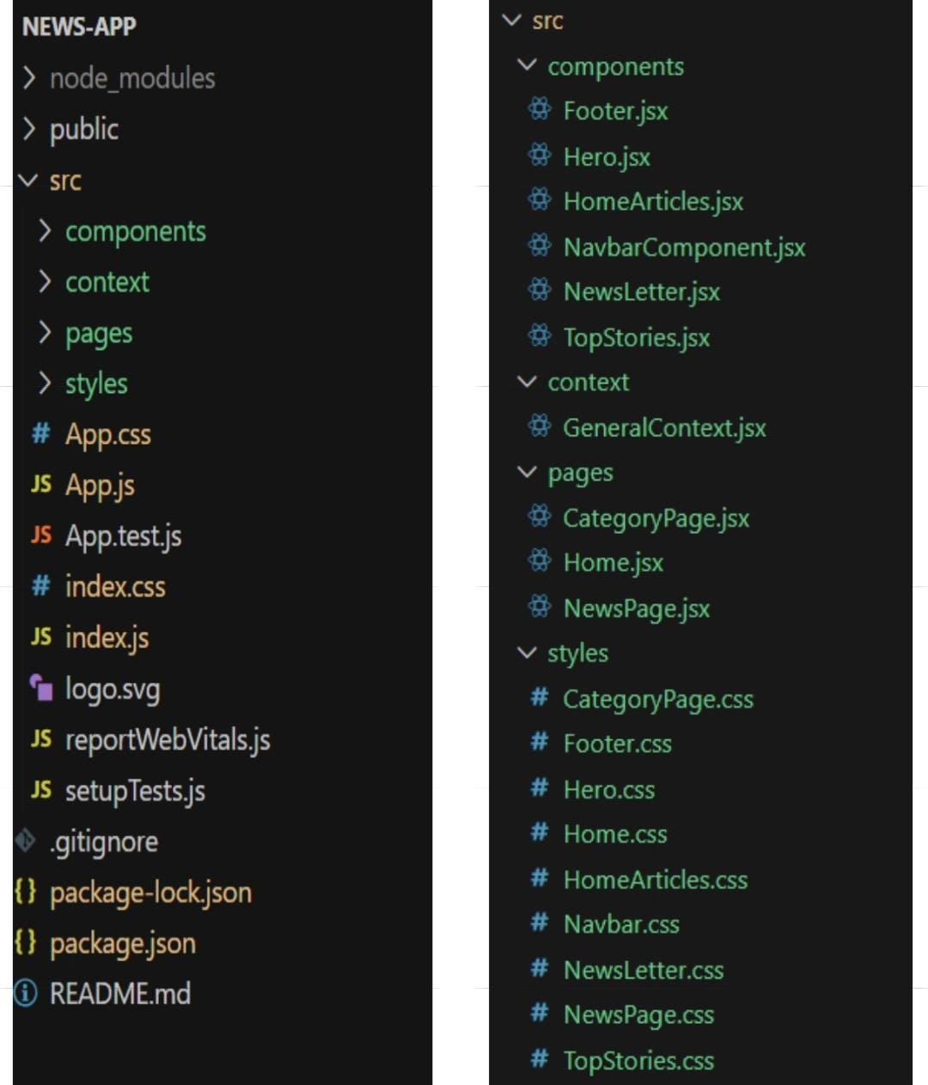

**Utilities:**

* **API Helper Functions**: Handles requests to NewsAPI.
* **Data Formatters**: Ensures news content is displayed in a readable format.

**Running the Application**

**To start the front-end server locally :**

### **Steps to Start the Front-End Server Directly in NEWS-APP**

1. **Navigate to the Project Directory:**
2. cd NEWS-APP
3. **Install Dependencies (if not installed):**
4. npm install
5. **Start the Development Server:**
6. npm start
7. **Access the Application:**
   * Open your browser and go to:  
     <http://localhost:3000/>

### **Steps to Start the Application in the Client Directory:**

1. **Navigate to the Client Directory:**
2. cd NEWS-APP/client
3. **Install Dependencies (if not installed):**
4. npm install
5. **Start the Development Server:**
6. npm start
7. **Access the Application:**
   * Open your browser and go to:  
     <http://localhost:3000/>

**Component Documentation**

**Key Components:**

* **Header & Footer**: Provides navigation links and branding elements.
* **News Feed**: Displays fetched news articles dynamically.
* **Subscription Form**: Allows users to sign up for email alerts.
* **Search Bar**: Enables users to find news on specific topics.
* **Category Filters**: Helps users browse articles based on selected topics.

**Reusable Components:**

* **Button**: Custom-styled button used throughout the app.
* **Card**: A reusable news display card component that presents article previews.
* **Modal**: Used for displaying additional article details or subscription confirmation.

**State Management**

**Global State:**

* **Context API**: Manages shared state across components, such as user subscriptions and selected filters.

**Local State:**

* **useState Hook**: Handles UI changes at the component level, such as search input and form submissions.

**User Interface**

The UI includes:

* **Home Page**: Displays featured news and top headlines.
* **News Feed Page**: Lists all available articles with options to filter and search.
* **Subscription Page**: Allows users to sign up for email updates.
* **Article Detail Page**: Shows the full content of a selected news article.

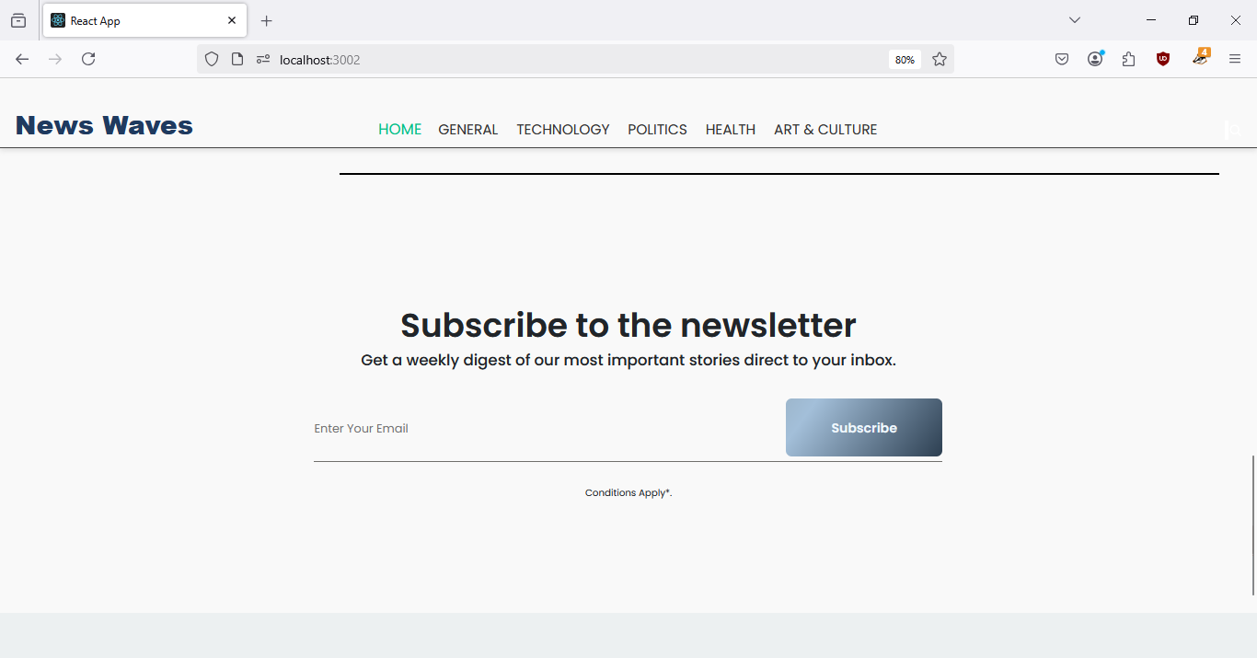

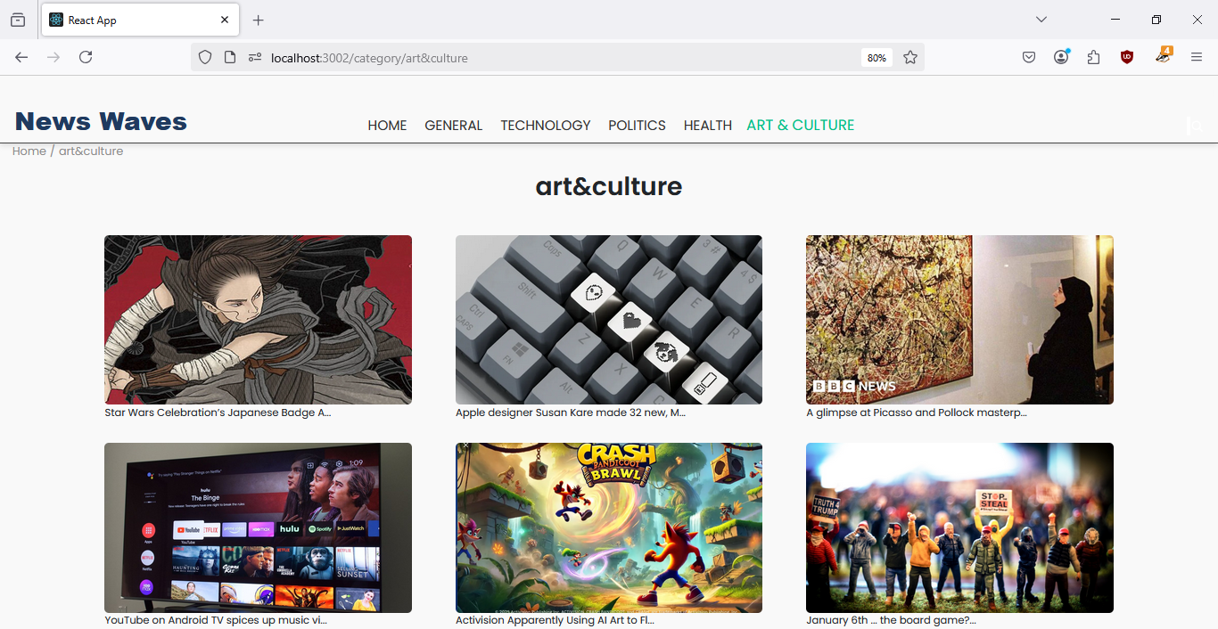

**Styling**

**CSS Frameworks/Libraries**

* **Styled-components**: Used for component-based styling.
* **Bootstrap**: Provides responsive layouts and pre-styled UI elements.

**Theming**

The app follows a clean and modern theme with:

* A blue and white color scheme for readability.
* Consistent typography and spacing.
* Dark Mode (Planned for future updates).

**Testing**

**Testing Strategy:**

* **Unit Testing**: Ensures individual components work as expected (using Jest and React Testing Library).
* **Integration Testing**: Tests interactions between components and API calls.
* **End-to-End Testing**: Planned for future enhancements.

**Code Coverage:**

* **Istanbul**: Used to ensure proper test coverage.
* **ESLint & Prettier**: Maintain code quality and consistency.

**Screenshots and Demo**

**Demo Link:**

<https://drive.google.com/file/d/1CUZ9YhxOIUkhWS7fKH7zW30dQTjqnwxX/view?usp=drivesdk>

**Screenshots :**

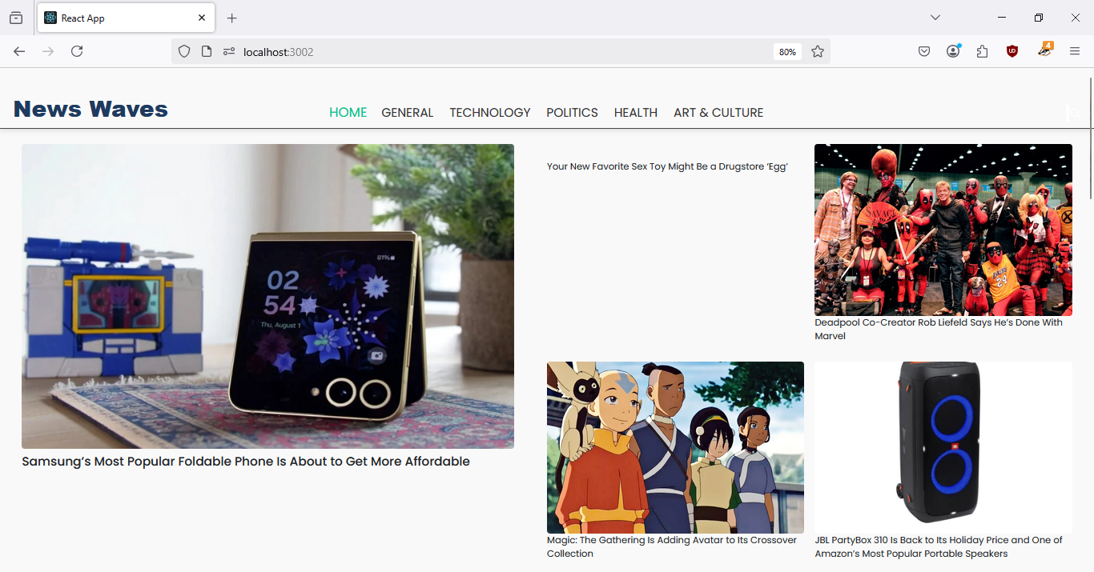

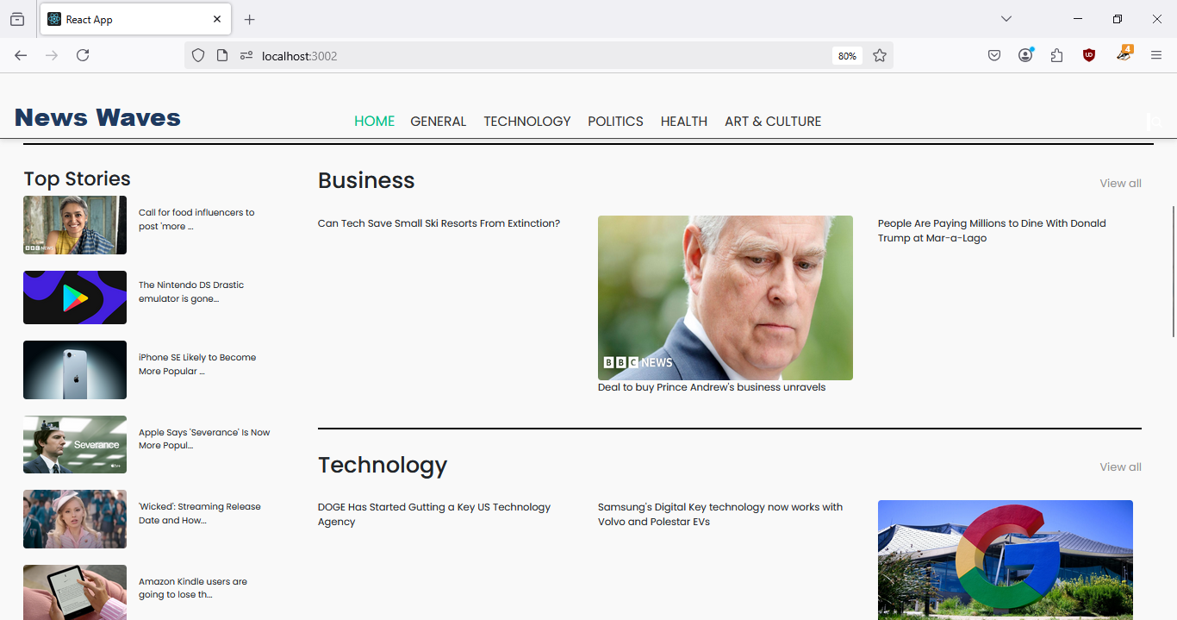



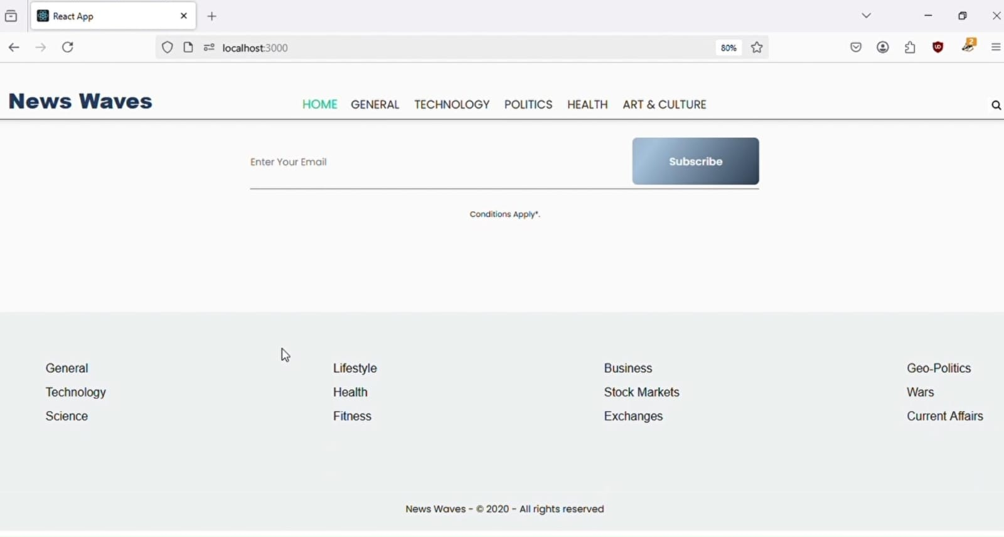



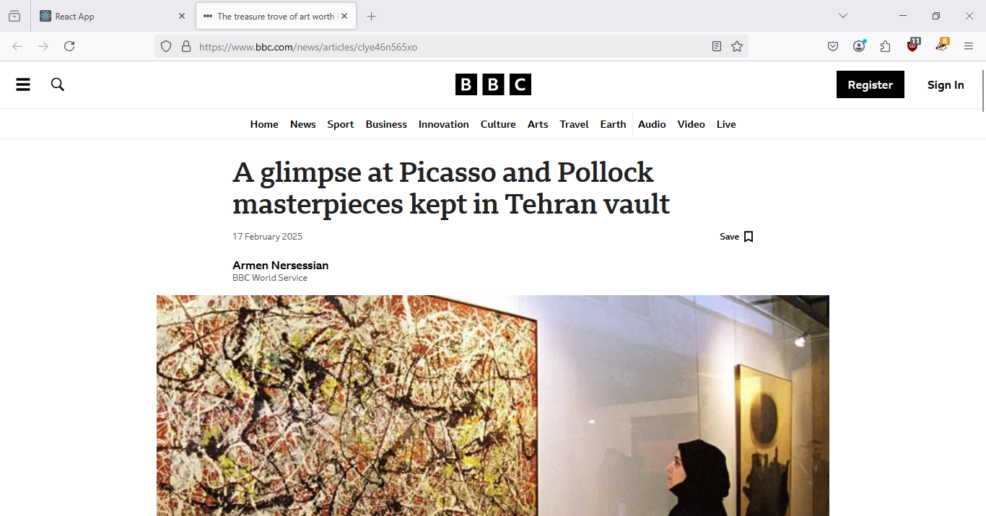

**Known Issues**

* Occasional API rate limit errors when fetching news.
* Subscription confirmation emails not yet implemented.
* Some layout inconsistencies in mobile view.

**Future Enhancements**

* **User Authentication**: Allow users to log in and save preferences.
* **Personalized News Feed**: Custom news recommendations based on user interests.
* **Dark Mode Support**: Provide a night-friendly reading experience.
* **Push Notifications**: Notify users of breaking news.
* **Bookmarking Feature**: Let users save articles for later reading.